**1**

**Identify various java IDEs and identify differences between them**

**There are several Java IDEs (Integrated Development Environments) available, each with its own set of features, strengths, and target audience. Here are some popular Java IDEs along with their key differences:**

Eclipse**: Eclipse is one of the most widely used Java IDEs. It's known for its extensibility through plugins, making it suitable for various development workflows and languages. Eclipse provides features such as code completion, debugging, refactoring, and version control integration. It's open-source and has a large community, which means there's a wide range of plugins available to extend its functionality. Eclipse is favored by many enterprise Java developers.**

IntelliJ IDEA**: Developed by JetBrains, IntelliJ IDEA is another popular Java IDE known for its intelligent code assistance, refactoring tools, and advanced code analysis. It offers features like smart code completion, version control integration, and a wide range of plugins. IntelliJ IDEA has a strong focus on developer productivity and offers editions tailored for different types of development, such as IntelliJ IDEA Community Edition (free) and IntelliJ IDEA Ultimate (commercial). It's particularly popular among Android developers and those working with Kotlin.**

NetBeans: **NetBeans is an open-source Java IDE supported by the Apache Software Foundation. It provides features like code templates, version control integration, and GUI development tools. NetBeans offers support for various programming languages besides Java, including PHP, HTML, and C/C++. It's known for its ease of use and comprehensive set of features out-of-the-box, making it suitable for beginners and experienced developers alike.**

Visual Studio Code (VS Code): **While not strictly a Java IDE, VS Code is a highly customizable code editor developed by Microsoft. It has a rich ecosystem of extensions that allow developers to tailor it to their needs, including support for Java development via extensions like "Java Extension Pack" or "Language Support for Java(TM) by Red Hat". VS Code is lightweight, fast, and offers features like debugging, code snippets, and Git integration. It's popular among developers working with a variety of programming languages, including Java.**

BlueJ: **BlueJ is an educational IDE designed primarily for beginners learning Java programming. It provides a simplified interface and visualization tools to help students understand object-oriented concepts. BlueJ is lightweight and focuses on simplicity, making it suitable for introductory programming courses.**

**1**

**2 . Compare and contrast Java with Python**

**Java and Python are both popular programming languages, but they have distinct differences in terms of syntax, usage, performance, and ecosystem. Here's a comparison between Java and Python:**

# **Syntax:**

**Java: Java is a statically-typed language, which means that variable types are declared at compile time. It uses braces {} to define code blocks and requires semicolons ; to terminate statements. Java code tends to be more verbose compared to Python.**

Python: **Python is dynamically-typed, allowing variables to be assigned without explicit type declarations. It uses indentation to define code blocks and does not require semicolons to terminate statements. Python syntax is generally more concise and readable compared to Java.**

# **Usage:**

**Java: Java is widely used in enterprise applications, web development (with frameworks like Spring and Hibernate), Android app development, and large-scale systems due to its performance, scalability, and strong typing.**

Python: **Python is versatile and used in various domains such as web development (with frameworks like Django and Flask), data analysis, machine learning, artificial intelligence, scripting, scientific computing, and automation. Its simplicity and readability make it popular among beginners and experienced developers alike.**

# **Performance:**

**Java: Java is a compiled language that typically offers faster performance than Python, especially for computation-intensive tasks. It's often preferred for performance-critical applications or systems where efficiency is crucial.**

Python: **Python is an interpreted language, which generally makes it slower than Java. However, Python's performance can be improved using libraries like NumPy and Cython for numerical computation or by integrating with performance-critical code written in languages like C or C++.**

# **Ecosystem:**

**Java: Java has a mature ecosystem with a vast array of libraries, frameworks, and tools for various purposes. It has extensive documentation and strong support from the community and the industry.**

Python: **Python's ecosystem is also rich and diverse, with a large number of libraries and frameworks available for different domains. Python's ecosystem is known for its simplicity and ease of use, fostering rapid development and prototyping.**

**Concurrency and Parallelism:**

**2**

# **1 Study and present**

**Introduction**

**Brief overview of Java and Python**

**Importance of understanding the differences between the two languages**

**Purpose of the study**

**1. Language Syntax and Features**

**Java syntax overview (static typing, braces, semicolons)**

**Python syntax overview (dynamic typing, indentation, simplicity)**

**Comparison of key language features (e.g., object-oriented programming, functional programming)**

**2. Usage and Application Areas**

**Java: enterprise applications, web development, Android app development, large-scale systems**

**Python: web development (Django, Flask), data analysis, machine learning, scripting, scientific computing, automation**

**Examples of companies or projects using each language in real-world scenarios**

**3. Performance Comparison**

**Java: compiled language, generally faster performance, suitability for performance-critical applications**

**Python: interpreted language, slower performance, optimizations with libraries like NumPy, Cython, integration with C/C++**

**4. Ecosystem and Community Support**

**Overview of Java ecosystem: libraries, frameworks, tools, documentation, community support**

**Overview of Python ecosystem: libraries, frameworks, tools, documentation, community support**

**Comparison of ecosystem strengths and weaknesses**

**5. Concurrency and Parallelism**

**Java: built-in support for multithreading and concurrency with java.util.concurrent package**

**Python: historical limitations in concurrency and parallelism, improvements with asyncio, multiprocessing**

**a. type casting in java**

**b. what are command line arguments in java?**

**c. java keywords and their usage**

**a. Type Casting in Java:**

**Type casting in Java is the process of converting a variable from one data type to another. There are two types of type casting: implicit casting (also known as widening conversion) and explicit casting (also known as narrowing conversion).**

* **Implicit Casting: In implicit casting, smaller data types are automatically promoted to larger data types. For example, converting an int to a double or a float to a double.**
* **Explicit Casting: In explicit casting, larger data types are manually converted to smaller data types. This type of casting requires the use of parentheses and may result in data loss if the value is too large for the target data type.**

**b. Command Line Arguments in Java:**

**Command line arguments allow you to pass arguments to a Java program when it is executed from the command line or terminal. These arguments are passed as strings and are stored in the args parameter of the main method.**

**c. Java Keywords and Their Usage:**

**Java keywords are reserved words that have predefined meanings in the Java language. These keywords cannot be used as identifiers (such as variable names, class names, or method names). Some common Java keywords include public, class, static, void, if, else, for, while, switch, case, break, continue, return, new, this, super, extends, implements,**

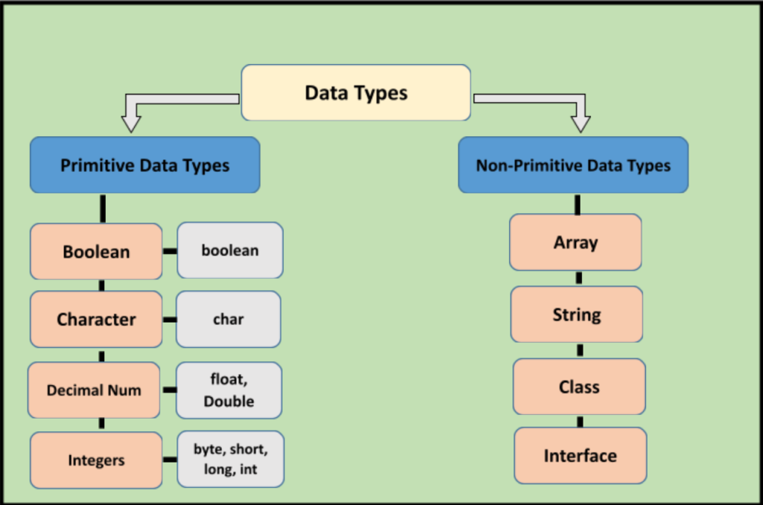

# **3**

# **Compare and contrast**

**a. method and constructor;**

**b. constructor and destructor**

**a. Method vs. Constructor:**

**Definition:**

**Method: A method is a block of code that performs a specific task and can be called from other parts of the program.**

**Constructor: A constructor is a special type of method that is automatically invoked when an object of a class is created. It initializes the object's state.**

# **Return Type:**

**Method: A method may have a return type (void or any other data type) or may return nothing.**

**Constructor: A constructor does not have a return type. Its purpose is to initialize the object, and it cannot return a value.**

# **Name:**

**Method: Methods have names that are used to call them explicitly.**

**Constructor: Constructors have the same name as the class and are invoked implicitly when an object is created.**

**Usage:**

**Method: Methods are used to define behavior or functionality of objects. They can be called multiple times within the program.**

**Constructor: Constructors are used to initialize the state of an object. They are called only once, at the time of object creation.**

**Accessibility:**

**Method: Methods can have different access modifiers (public, private, protected, default) to control their visibility and accessibility.**

**Constructor: Constructors can also have access modifiers, but they are often public to allow object creation from outside the class.**

# **b. Constructor vs. Destructor:**

**Definition:**

**Constructor: As mentioned earlier, a constructor is a special method used to initialize objects. It is called automatically when an object is created.**

**Destructor: Unlike Java, in languages like C++ and C#, there's a concept of a destructor, which is a special member function invoked automatically when an object goes out of scope or is explicitly deleted. It's used to release resources allocated by the object.**

**Invocation:**

**Constructor: Constructors are invoked implicitly at the time of object creation.**

**Destructor: Destructors are invoked implicitly when an object is destroyed or goes out of scope.**

**Purpose:**

**Constructor: Constructors are used to initialize the state of an object, allocate memory, and perform any necessary setup.**

**Destructor: Destructors are used to release resources acquired by an object during its lifetime, such as memory or file handles. They're often used for cleanup tasks.**

**Explicit Invocation:**

**Constructor: Constructors cannot be explicitly called from within the program. They're automatically invoked when an object is created.**

**Destructor: Destructors are not explicitly called in languages like Java. In languages with explicit destructors, they can be invoked manually, but it's not common practice.**

# **4**

# **Study and present how does bytecode work in java**

**Title: Understanding Bytecode in Java: The Intermediate Representation**

# **Introduction:**

**Brief overview of bytecode.**

**Importance of bytecode in Java programming.**

**Purpose of the study.**

# **1. What is Bytecode?**

**Definition of bytecode.**

**Explanation of bytecode as an intermediate representation between source code and machine code.**

**Bytecode's role in platform independence.**

**2. Compilation Process in Java:**

**Overview of the Java compilation process.**

**Source code compilation to bytecode using the Java compiler (javac).**

**Generation of .class files containing bytecode.**

**3. Structure of Bytecode:**

**Explanation of bytecode instructions.**

**Bytecode as a set of instructions for the Java Virtual Machine (JVM).**

**Examples of common bytecode instructions (e.g., aload, iconst, invokevirtual, return).**

**4. Execution of Bytecode:**

**Introduction to the Java Virtual Machine (JVM).**

**Role of the JVM in executing bytecode.**

**Steps involved in bytecode execution: loading, linking, and initialization.**

**5. Advantages of Bytecode:**

**Platform independence: bytecode runs on any system with a JVM.**

**Security: bytecode execution within the JVM sandbox.**

**Performance optimization by the JVM (e.g., Just-In-Time compilation).**

**6. Disadvantages of Bytecode:**

**Overhead of interpreting bytecode.** 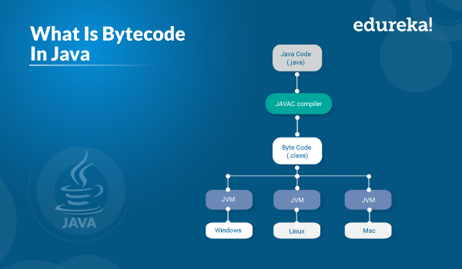

# **5**

# **Present nesting of conditional and iterative statements considering a use case.**

**def main():**

**# Initialize variables**

**total_items = 0**

**total_cost = 0**

**shopping_cart = []**

**# Simulate shopping process**

**while True:**

**print("Welcome to the Online Store!")**

**print("1. Add item to cart")**

**print("2. Remove item from cart")**

**print("3. View cart")**

**print("4. Checkout")**

**print("5. Exit")**

**choice = input("Enter your choice: ")**

**if choice == "1":**

**item_name = input("Enter item name: ")**

**item_price = float(input("Enter item price: "))**

**shopping_cart.append((item_name, item_price))**

**total_items += 1**

**total_cost += item_price**

**print("Item added to cart.")**

**elif choice == "2":**

**if total_items == 0:**

**print("Your cart is empty.")**

**else:**

**print("Your cart:")**

**for index, item in enumerate(shopping_cart):**

**print(f"{index + 1}. {item[0]} - ${item[1]}")**

**remove_index = int(input("Enter the index of item to remove: ")) - 1**

**if 0 <= remove_index < len(shopping_cart):**

**removed_item = shopping_cart.pop(remove_index)**

**total_items -= 1**

**total_cost -= removed_item[1]**

**print(f"{removed_item[0]} removed from cart.")**

**else:**

**print("Invalid index.")**

**elif choice == "3":**

**if total_items == 0:**

**print("Your cart is empty.")**

**else:**

**print("Your cart:")**

**for index, item in enumerate(shopping_cart):**

**print(f"{index + 1}. {item[0]} - ${item[1]}")**

**print(f"Total items: {total_items}")**

**print(f"Total cost: ${total_cost}")**

**elif choice == "4":**

**if total_items == 0:**

**print("Your cart is empty. Please add items before checkout.")**

**else:**

**print("Checkout successful!")**

**print(f"Total items: {total_items}")**

**print(f"Total cost: ${total_cost}")**

**break**

**elif choice == "5":**

**print("Thank you for shopping with us!")**

**break**

**else:**

**print("Invalid choice. Please enter a number between 1 and 5.")**

**if __name__ == "__main__":**

**6**

# **Identify advantages and disadvantages of**

**a. Encapsulation.**

**b. Inheritance**

**c. Abstraction**

**d. Polymorphism**

**a. Encapsulation:**

# **Advantages:**

**Data Hiding: Encapsulation allows hiding the internal state of an object from the outside world, providing a clear interface for interacting with the object. This enhances security and prevents accidental misuse of data.**

Modularity: **Encapsulation promotes modularity by grouping related variables and methods into a single unit (class), making it easier to understand, maintain, and modify the code.**

Code Flexibility: **By encapsulating data and behavior within objects, changes to the internal implementation details can be made without affecting the code that uses those objects. This enhances code flexibility and promotes code reusability.**

# **Disadvantages:**

**Increased Complexity: Encapsulation can sometimes lead to increased complexity, especially when dealing with a large number of classes and complex interactions between them.**

**Performance Overhead: There might be a slight performance overhead associated with encapsulation due to the need for method calls to access or modify encapsulated data, compared to direct access.**

# **b. Inheritance:**

# **Advantages:**

**Code Reusability: Inheritance allows a subclass to inherit properties and behavior (methods) from its superclass, promoting code reuse and reducing redundancy.**

**Polymorphism: Inheritance enables polymorphic behavior, where objects of different subclasses can be treated as objects of the superclass, facilitating dynamic method invocation and flexibility in programming.**

**Extensibility: Inheritance facilitates extending existing classes to create new ones, providing a way to add new features or modify existing behavior without modifying the original class.**

# **Disadvantages:**

**Inflexibility: Inheritance creates a tight coupling between the superclass and its subclasses, making it difficult to modify the superclass without affecting its subclasses. Changes in the superclass may require modifications in all its subclasses.**

**Hierarchy Maintenance: Inheritance hierarchies can become complex and difficult to manage, especially in large-scale projects, leading to maintenance challenges and potential design flaws.**

**Overuse: Overusing inheritance can lead to a rigid class structure and hinder code maintainability, as it may become harder to understand and navigate.**

**c. Abstraction:**

# **Advantages:**

**Simplification: Abstraction hides complex implementation details and exposes only essential features, making the interface simpler and easier to understand for users.**

**Modularity: Abstraction promotes modularity by allowing the implementation details to be encapsulated within a module or class, reducing complexity and improving code organization.**

**Flexibility: Abstraction allows changes to the implementation details without affecting the code that uses the abstraction, providing flexibility and facilitating code evolution.**

# **Disadvantages:**

**Overhead: Implementing abstraction may introduce additional overhead, such as the need for defining interfaces, abstract classes, or additional layers of indirection, which can impact performance and increase complexity.**

**Misuse: Improper abstraction can lead to overly abstract or overly complex designs, making the code difficult to understand and maintain. Finding the right level of abstraction is crucial.**

**d. Polymorphism:**

# **Advantages:**

**Code Flexibility: Polymorphism allows objects of different types to be treated uniformly through a common interface, enabling more flexible and generic code that can work with various object types without the need for explicit type checking.**

**Code Reusability: Polymorphism promotes code reusability by enabling the same code to be used with different types of objects, reducing redundancy and promoting modular design.**

**Extensibility: Polymorphism facilitates the addition of new classes and types without modifying existing code, promoting extensibility and enabling the evolution of software systems.**

# **Disadvantages:**

**Complexity: Polymorphism can introduce complexity, especially when dealing with large codebases or complex inheritance hierarchies, making the code harder to understand and maintain.**

**Performance Overhead: Dynamic polymorphism (e.g., method overriding) may incur a slight performance overhead due to the need for method resolution at runtime, compared to static method invocation.**

**Potential for Misuse: Improper use of polymorphism, such as excessive method overriding or overly complex class hierarchies, can lead to code that is difficult to understand, debug, or extend.**

**7**

# **Study and report**

**a. java Arrays class their methods**

**b. java String class their methods**

**a. Java Arrays class:**

**The Arrays class in Java provides various utility methods for working with arrays. It's part of the java.util package. Here are some commonly used methods:**

**sort(T[] a): Sorts the specified array of objects into ascending order.**

**toString(T[] a): Returns a string representation of the contents of the specified array.**

**binarySearch(T[] a, T key): Searches the specified array for the specified object using the binary search algorithm.**

**copyOf(T[] original, int newLength): Copies the specified array, truncating or padding with zeros (if necessary) so the copy has the specified length.**

**fill(T[] a, T val): Assigns the specified value to each element of the specified array.**

**And many more. These methods offer a convenient way to manipulate arrays without having to write custom implementations.**

# **b. Java String class:**

**The String class represents a sequence of characters. It's part of the java.lang package and is one of the most commonly used classes in Java. Here are some important methods of the String class:**

**charAt(int index): Returns the character at the specified index.**

**length(): Returns the length of this string.**

**substring(int beginIndex): Returns a new string that is a substring of this string, starting from the specified index.**

**concat(String str): Concatenates the specified string to the end of this string.**

**indexOf(String str): Returns the index within this string of the first occurrence of the specified substring.**

**toUpperCase(): Converts all of the characters in this String to uppercase.**

**toLowerCase(): Converts all of the characters in this String to lowercase.**

**trim(): Returns a copy of the string, with leading and trailing whitespace removed.**

**8**

# **Identify and document how these principles help to avoid code smells.**

**a. SRP**

**b. OCP**

**c. ISP**

# **a. Single Responsibility Principle (SRP):**

**The Single Responsibility Principle states that a class should have only one reason to change, meaning it should have only one responsibility. By adhering to SRP, we ensure that each class focuses on doing one thing well, which helps to avoid several code smells:**

**God Class: SRP helps to prevent the creation of god classes, which try to do too much and are responsible for numerous functionalities. Such classes often become difficult to maintain, understand, and test.**

**Feature Envy: When a class is responsible for multiple concerns, it may lead to feature envy, where methods in the class heavily depend on data or functionality of other classes, indicating a violation of SRP.**

**High Coupling: Classes with multiple responsibilities tend to have higher coupling, as they rely on many other classes or modules to fulfill those responsibilities. High coupling makes the codebase rigid and difficult to change.**

**By adhering to SRP, each class becomes focused and cohesive, reducing the likelihood of these code smells and making the codebase more maintainable, readable, and testable.**

# **b. Open/Closed Principle (OCP):**

**The Open/Closed Principle states that software entities (such as classes, modules, functions, etc.) should be open for extension but closed for modification. This principle helps to avoid code smells by promoting code that is flexible and easily extensible:**

**Rigidity: Without adhering to OCP, making changes to existing code often requires modifications to multiple parts of the codebase, leading to rigidity. Changes in one part of the code cascade to other parts, making maintenance challenging.**

**Fragility: Fragility occurs when making a seemingly small change in one part of the codebase unexpectedly breaks other parts. This is a common problem when the code is not closed for modification.**

**Complexity: Violating OCP often leads to complex conditional logic scattered throughout the codebase to accommodate new requirements, resulting in harder-to-understand code.**

**By designing classes and modules that are open for extension through inheritance, composition, or other means, and closed for modification, we can mitigate these code smells and create code that is more robust and resilient to change.**

# **c. Interface Segregation Principle (ISP):**

**The Interface Segregation Principle states that clients should not be forced to depend on interfaces they do not use. It helps to avoid code smells related to unnecessary dependencies and interface bloat:**

**Interface Pollution: Without adhering to ISP, interfaces may become bloated with methods that are not relevant to all implementing classes. This leads to interface pollution, where implementing classes are forced to implement unnecessary methods.**

**Client Dependencies: Violating ISP often results in clients depending on interfaces containing methods they don't use. This leads to unnecessary coupling between clients and interfaces, making the codebase more fragile and less maintainable.**

**Rigidity: ISP violations can make the codebase rigid, as changes to interfaces affect all implementing classes, even those that do not use the new functionality.**

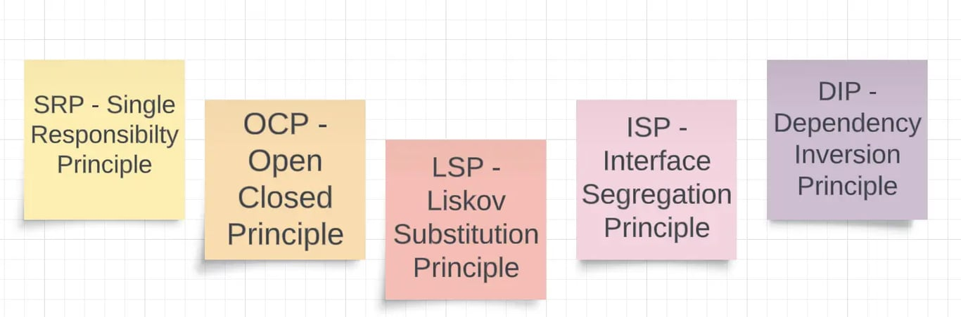

# **9**

# **Compare and contrast**

**a. static and dynamic binding and identify usage of each**

**b. abstract class and interface, identify usage of each**

**a. Static and Dynamic Binding:**

# **Static Binding:**

**Static binding, also known as early binding, occurs during compile-time.**

**In static binding, the method call is resolved based on the type of the reference variable.**

**It is used in method overloading (compile-time polymorphism) where the decision of which method to call is made at compile-time based on the reference type.**

**Example usage: Method overloading, where different methods with the same name but different parameters are defined in the same class.**

# **Dynamic Binding:**

**Dynamic binding, also known as late binding, occurs during runtime.**

**In dynamic binding, the method call is resolved based on the actual object type at runtime.**

**It is used in method overriding (runtime polymorphism) where the decision of which method to call is made at runtime based on the actual object type.**

**Example usage: Method overriding, where a subclass provides a specific implementation of a method defined in its superclass.**

# **Comparison:**

**Static binding is faster as the method resolution is done at compile-time.**

**Dynamic binding provides more flexibility and allows for polymorphic behavior.**

**Static binding is suitable for method overloading where different versions of methods with the same name are defined, whereas dynamic binding is suitable for method overriding to achieve polymorphic behavior.**

# **b. Abstract Class and Interface:**

# **Abstract Class:**

**An abstract class is a class that cannot be instantiated and may contain abstract methods (methods without implementation) and concrete methods.**

**It can have constructors, member variables, and regular methods along with abstract methods.**

**Abstract classes can provide a partial implementation of a class and can be subclassed using inheritance.**

**Example usage: Abstract classes are used to define a common interface for a group of related classes. They are suitable for providing a base implementation for multiple subclasses.**

# **Interface:**

**An interface in Java is a reference type similar to a class but only contains abstract methods, constants, and nested types.**

**It cannot have constructors, instance variables, or concrete methods.**

**Interfaces define a contract for classes to implement, providing a way to achieve multiple inheritances through implementation.**

**Example usage: Interfaces are used to define a contract that classes can implement. They are suitable for defining behaviors that multiple unrelated classes can share, enabling polymorphism and loose coupling.**

# **Comparison:**

**Abstract classes can have constructors and member variables, while interfaces cannot.**

**A class can implement multiple interfaces but can only extend one abstract class.**

**Abstract classes can provide a default implementation for some methods, whereas interfaces cannot provide any implementation.**

**Abstract classes are suitable for defining common behavior and shared functionality among related classes, while interfaces are suitable for defining contracts and enabling multiple inheritances in Java.**

# **10**

# **Differentiate error and exception**

# **Errors:**

**Errors are typically severe problems that occur at runtime and are usually beyond the control of the programmer.**

**Errors indicate serious issues that often cannot be handled by the program itself, such as out-of-memory errors (OutOfMemoryError), stack overflow errors (StackOverflowError), or internal system errors.**

**Errors are unchecked and are not meant to be caught or handled by the application code. They represent fundamental problems that usually require intervention at a higher level (e.g., by system administrators or developers).**

**Examples of errors in Java: OutOfMemoryError, StackOverflowError, NoSuchMethodError.**

# **Exceptions:**

**Exceptions are problems that occur during the execution of a program and can be handled by the program itself.**

**Exceptions can arise due to various reasons, such as invalid user input, incorrect file operations, network issues, or other unexpected conditions.**

**Exceptions in Java are objects of type Throwable or its subclasses, which represent exceptional conditions that can be caught and handled by exception handling mechanisms.**

**Exceptions can be categorized into two types: checked exceptions and unchecked exceptions. Checked exceptions (e.g., IOException) must be declared in the method signature or handled using try-catch blocks, while unchecked exceptions (e.g., NullPointerException) do not need to be explicitly handled.**

**Examples of exceptions in Java: IOException, NullPointerException, ArrayIndexOutOfBoundsException.**

# **Identify and document system exceptions**

**NullPointerException:**

**Thrown when attempting to access or perform operations on a null object reference.**

**Example scenarios: Calling methods or accessing fields on a null object reference, attempting to access elements of a null array.**

**ArrayIndexOutOfBoundsException:**

**Thrown when attempting to access an array element with an invalid index (either negative or greater than or equal to the array's length).**

**Example scenarios: Accessing an index that is out of bounds for an array.**

**IndexOutOfBoundsException:**

**Thrown when attempting to access a collection element with an invalid index.**

**Example scenarios: Accessing an index that is out of bounds for a list or other collection types.**

**ArithmeticException:**

**Thrown when an arithmetic operation results in an overflow, underflow, or division by zero.**

**Example scenarios: Attempting to divide by zero, performing an arithmetic operation that results in overflow or underflow.**

**ClassNotFoundException:**

**Thrown when an application tries to load a class through its string name using a method such as Class.forName(), but no definition for the class with the specified name could be found.**

**Example scenarios: Attempting to load a class dynamically using its name, but the class is not found in the classpath.**

**IllegalArgumentException:**

**Thrown when a method receives an argument of an inappropriate type or value.**

**Example scenarios: Passing an illegal argument to a method, such as a negative value to a method that expects a non-negative integer.**

**IllegalStateException:**

**Thrown when the state of an object is not suitable for the operation being called.**

**Example scenarios: Calling a method on an object when it is in an invalid state, such as invoking a method on a closed file or stream.**

**IOException:**

**Thrown when an input/output operation fails or is interrupted.**

**Example scenarios: Reading from or writing to a file, socket, or stream encounters an error, such as file not found, permission denied, or network failure.**

**NumberFormatException:**

**Thrown when attempting to convert a string to a numeric format, but the string does not have the appropriate format.**

**Example scenarios: Parsing a string that is not a valid representation of a number, such as parsing "abc" as an integer.**

**11**

# **Study DRY principle, identify the benefits.**

* **Code Reusability: By abstracting common functionality into reusable components, the DRY principle promotes code reusability. Instead of duplicating code in multiple places, developers can write modular and reusable code that can be easily shared and reused across different parts of the application. This reduces the amount of code that needs to be written and maintained.**
* **Improved Maintainability: Duplicated code increases the maintenance burden on developers. When the same functionality is repeated in multiple places, any changes or updates to that functionality must be made in each instance of the duplicated code. This can lead to inconsistencies, errors, and increased effort during maintenance. Adhering to the DRY principle reduces duplication, making the codebase easier to maintain and modify.**
* **Enhanced Readability: Duplicated code can make the codebase harder to read and understand. When the same logic is scattered throughout the codebase, it becomes more challenging for developers to grasp the overall structure and flow of the application. By centralizing common functionality into reusable components, the DRY principle improves code readability and comprehension.**

* **Consistency and Accuracy: Duplicated code increases the risk of inconsistencies and errors. If changes are made to one instance of duplicated code but not propagated to other instances, it can lead to inconsistencies in behavior and unintended side effects. By eliminating duplication through the DRY principle, developers can ensure that changes and updates are applied consistently across the codebase, reducing the risk of errors and improving overall code quality.**
* **Simplified Testing: Duplicated code requires redundant testing efforts to ensure that the same functionality behaves consistently across all instances. By reducing duplication, the DRY principle simplifies testing efforts by enabling developers to focus on testing the functionality in one central location rather than multiple instances of duplicated code. This improves test coverage and reduces the likelihood of overlooking edge cases or bugs.**

# **12**

# **Identify how OOD principles violations impact the quality of code.**

**Violating Object-Oriented Design (OOD) principles can have significant negative impacts on the quality of code. Here are several ways in which violations of OOD principles can impact code quality:**

* **Reduced Maintainability: OOD principles such as the Single Responsibility Principle (SRP) and the Open/Closed Principle (OCP) promote modular, loosely coupled designs that are easier to maintain and extend. When these principles are violated, code becomes tightly coupled, and changes to one part of the system can have unintended consequences on other parts. This makes the codebase more fragile and difficult to maintain over time.**
* **Decreased Reusability: OOD principles encourage the creation of reusable components and modular designs. Violations of these principles often lead to code duplication, where similar functionality is implemented in multiple places. This not only increases the amount of code that needs to be maintained but also reduces the opportunity for reuse, as developers are more likely to copy and paste code rather than extracting common functionality into reusable components.**
* **Increased Complexity: OOD principles help to manage complexity by breaking down systems into smaller, more manageable components. Violations of these principles can result in overly complex designs with tangled dependencies and unclear responsibilities. This makes it harder for developers to understand the codebase, leading to longer development times, increased debugging efforts, and a higher likelihood of introducing defects.**
* **Poor Scalability: OOD principles promote designs that are flexible and scalable, allowing systems to evolve and grow over time. When these principles are violated, code becomes tightly coupled and monolithic, making it difficult to introduce new features or make changes without affecting other parts of the system. This can hinder the ability of the software to adapt to changing requirements and scale to meet the needs of users.**
* **Decreased Testability: OOD principles such as Dependency Inversion Principle (DIP) and Interface Segregation Principle (ISP) promote designs that are easier to test in isolation. Violating these principles can result in code that is tightly coupled and difficult to test, as dependencies are hardcoded and cannot be easily replaced with mocks or stubs. This can lead to decreased test coverage, increased risk of defects, and longer testing cycles.**

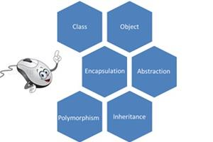

# **13**

# **Identify java ORM frameworks and their features.**

**Java ORM (Object-Relational Mapping) frameworks facilitate the mapping of Java objects to relational database tables, simplifying database interactions and reducing the amount of boilerplate code required. Here are some popular Java ORM frameworks along with their features:**

# **Hibernate:**

# **Features:**

**Comprehensive mapping strategies for entities, relationships, and inheritance hierarchies.**

**Automatic generation of SQL queries for CRUD (Create, Read, Update, Delete) operations.**

**Lazy loading and eager loading for efficient fetching of related entities.**

**Support for caching to improve performance.**

**Integration with Java Persistence API (JPA) specifications.**

**Support for annotations and XML configuration.**

**Advanced features like batch processing, optimistic locking, and detached objects.**

**Community: Hibernate has a large and active community with extensive documentation and support.**

# **EclipseLink:**

# **Features:**

**Full implementation of JPA specifications.**

**Support for advanced JPA features such as caching, locking, and transactions.**

**Compatibility with various databases and application servers.**

**High-performance database access through features like connection pooling and statement caching.**

**Support for XML and annotation-based mappings.**

**Integration with Eclipse IDE.**

**Support for NoSQL databases and object databases in addition to relational databases.**

**Community: EclipseLink has a strong community and is actively developed and maintained.**

**Spring Data JPA:**

# **Features:**

**Integration with the Spring framework, allowing for easy configuration and dependency injection.**

**Simplified repository pattern for defining database access methods.**

**Support for JPA specifications, including JPQL (Java Persistence Query Language) and Criteria API.**

**Automatic generation of CRUD operations based on method naming conventions.**

**Support for pagination, sorting, and dynamic queries.**

**Integration with Spring Data repositories for NoSQL databases like MongoDB and Redis.**

**Easily extensible through custom repository implementations.**

**Community: Spring Data JPA is part of the larger Spring ecosystem and benefits from a strong community and extensive documentation.**

**MyBatis:**

**Features:**

**SQL mapping framework that allows developers to map SQL queries to Java methods and objects.**

**Support for both XML and annotation-based configuration.**

**Dynamic SQL capabilities for building complex queries at runtime.**

**Simplified handling of result mapping and parameter mapping.**

**Integration with JDBC for low-level database interactions.**

**Lightweight and easy to configure.**

**Provides control over SQL queries and execution, making it suitable for developers who prefer working with SQL.**

**Community: MyBatis has an active community and is widely used in projects that require more control over SQL queries.**

**QueryDSL:**

**Features:**

**Type-safe querying framework for building SQL-like queries in Java.**

**Provides a fluent API for constructing queries using Java objects and methods.**

**Supports various SQL dialects and database types.**

**Integration with JPA, Hibernate, JDO (Java Data Objects), and other persistence frameworks.**

**Enables compile-time validation of queries, reducing the risk of runtime errors.**

# **14**

# **Study and find the inclusions in latest java versions.**

**Java 17 (September 2021):**

**Sealed Classes and Interfaces: Introduces sealed classes and interfaces, which restrict which classes can extend or implement them.**

**Pattern Matching for Switch: Enhances the switch statement to simplify code by enabling pattern matching and deconstruction of objects.**

**Foreign Function and Memory API: Introduces an API for interacting with native code and native memory directly from Java.**

**Strong encapsulation of JDK internals by default: Improves security by making internal APIs inaccessible by default.**

**Deprecates and removes several APIs and features, including the Applet API, RMI Activation, and the Security Manager.**

# **Java 16 (March 2021):**

Records: **Introduces records as a new type of class for modeling data with a fixed set of properties. Records automatically generate constructors, accessors, equals(), hashCode(), and toString() methods.**

Pattern Matching for instanceof: **Enhances the instanceof operator to simplify code by enabling pattern matching and deconstruction of objects.**

Unix-Domain Socket Channels: **Adds support for Unix domain socket channels in the java.nio.channels package.**

Alpine Linux Support: **Introduces support for running Java applications on Alpine Linux distributions.**

# **Java 15 (September 2020):**

**Sealed Classes (Preview): Introduces sealed classes and interfaces as a preview feature, allowing developers to restrict which classes can extend or implement them.**

**Hidden Classes: Introduces the java.lang.invoke package, providing access to non-public Java language features.**

**ZGC (Z Garbage Collector) Improvements: Enhances the ZGC garbage collector with features like concurrent class unloading and NUMA-aware memory allocation.**

**Text Blocks: Enhances the language with text blocks, providing a more natural way to express multi-line strings.**

# **Java 14 (March 2020):**

Records (Preview): **Introduces records as a preview feature, providing a concise syntax for declaring classes that are primarily intended to store data.**

Switch Expressions (Standard): **Enhances the switch statement to support both traditional and new expression-based syntax.**

Text Blocks (Preview): **Introduces text blocks as a preview feature, providing a more readable and maintainable way to write multi-line strings.**

JFR Event Streaming: **Adds support for continuous monitoring and analysis of Java applications using Java Flight Recorder (JFR).**

